|  |  |  |
| --- | --- | --- |
| Bangladesh Journal of Veterinary and Animal Sciences, Vol. 11, No. 2, July - December 2023 | | |
| **Bangladesh Journal of Veterinary and Animal Sciences**  pISSN 2227-6416  eISSN 2709-2542  Journal home page: www.bjvas.com | | |
| ***Research article***  **Anaesthetics and surgical evaluation of splenectomy in calves**  ***Bhajan Chandra Das1*, Avi Das2, Thomby Paul1, Debashish Sarker1, Bibek Chandra Sutradhar1 and AMAM Zonaed Siddiki2***  1Department of Medicine and Surgery, Chattogram Veterinary and Animal Sciences University, Chattogram-4225, Bangladesh  2Department of Pathology and Parasitology, Chattogram Veterinary and Animal Sciences University, Chattogram-4225, Bangladesh | | |
| ARTICLE INFO |  | ABSTRACT |
| Article history:  Received: 13/11/2023  Accepted: 28/02/2024 |  | Splenectomy is an effective therapeutic procedure for a wide range of medical disorders in humans and small animals, but in calves, splenectomy has mostly been used for experimental purposes rather than surgical affections. Either therapeutic or research purposes, successful splenectomy is very important. Therefore, the objective of the study was to analyze the anaesthetics and surgical efficacy of splenectomy in calves. The study was performed in three calves at Shahedul Alam Quadary Teaching Veterinary Hospital (SAQTVH) (case no. 1), Chattogram Veterinary and Animal Sciences University (CVASU) and Bangladesh Livestock Research Institute (BLRI) (case no. 2 and 3), Savar, Dhaka. Under xylazine and ketamine-based general anesthesia, linear infiltration, and/or paravertebral anesthesia with 2% lidocaine hydrochloride, splenectomy was carried out on left flank region specifically parallel and posterior to the last rib. Post-operatively, antibiotics, pain killer, antihistaminic, and topical ointment were given. All calves demonstrated uneventful recovery with specific aftercare at 14th postoperative day. Case no. 1 was euthanized at 15th post-operative day and case no. 2 and 3 managed to survive (230 days) with the history of retardation of growth. The present study suggests that the splenectomy can be successfully performed by just caudal and parallel to the last rib approach under xylazine and ketamine combination with local infiltration and/ or distal paravertebral anaesthesia. Adequate postoperative care also need to be considered as an integral part for successful recovery of the post splenectomy. |
| *Keywords:*  anaesthetics, calves, splenectomy, surgical evaluation |
| *\*Corresponding author:*  Cell: +88019303707316  E-mail: [bhajan@cvasu.ac.bd](mailto:bhajan@cvasu.ac.bd) |
| ***To cite this paper:*** *B. C. Das, A. Das, T. Paul, D. Sarker, B. C. Sutradhar and AMAM Z. Siddiki, 2023. Anaesthetics and surgical evaluation of splenectomy in calves. Bangladesh Journal of Veterinary and Animal Sciences, 11(2):18 -23.* | | |

1. **INTRODUCTION**

The spleen is a secondary lymphatic organ located almost vertically on the dorsal sac of the rumen and the cranial surface of the reticulum on the left side of the abdomen in cattle, extending from last two ribs to the costochondral junctions of the 7th and 8th ribs (Braun and Sicher, 2006). In ruminants, the

spleen comprises a white pulp region with a lymphatic function and a red pulp region for vascular function, including haematopoiesis, lymphopoiesis, haemoglobin processing, phagocytosis, immunological response and serves as a blood cell reservoir (Santos et al., 2013; Robewrtson and Newman, 2000). Splenectomy serves various therapeutic and research purposes in both humans and animals. In human, it is used to treat for common diseases like immune thrombocytopenic purpura, lymphoproliferative disorders, Hodgkin's disease and certain anemia (Mittelman et al., 1997). In animals, splenectomy is often for research on blood parasites and immunology (Coetzee and Apley, 2006), as well as for treating conditions like splenic rupture, torsion, and suppurative splenitis (Garcia-Seeber et al., 2008; Smith and Dallap, 2005; Nuss et al., 2009; Quinlan et al., 1935). In calves, splenectomy is commonly carried out for research in hemoparasitic diseases such as anaplasmosis and babesiosis while investigating the epidemiology of bovine hemoparasitic diseases. Splenectomized calves are used in the antigen production against these haemoparasitic diseases as well as for subinoculation diagnostic tests (El-Guindi, 1974).

However, the success of all kinds of therapeutic or research activity depend on successful management of splenectomy in the animal to achieve the goal of the research. There is limited information regarding the anaesthetic protocol for splenectomy in calves. Local anaesthesia is generally preferred for ruminant but due to anatomical location of the spleen, it is not currently a viable option to perform splenectomy. Though general anaesthesia is typically not suitable for ruminants, but calves don’t have functional rumen yet and literature suggests that we can go for general anaesthesia in calves. Different surgical approaches are used for splenectomy in calves. Based on the anatomical location of the spleen we attempted to see the feasibility of left flank approach by incising caudal and parallel to the last rib. The aim of the study was to evaluate the anaesthetic and surgical efficacy of splenectomy in calves, crucial for successful research outcomes.

**2. MATERIALS AND METHODS**

**Case description**

The study was conducted on three apparently healthy, 80% Holstein Friesian cross-bred, male calves. Case no. 1 was operated at Shahedul Alam Quadary Teaching Veterinary Hospital (SAQTVH), Chattogram Veterinary and Animal Sciences University (CVASU) (Figure 1), and case no. 2 and 3 were splenectomized at Bangladesh Livestock Research Institute (BLRI), Dhaka. The physical examination of all calves was normal, and the body condition score (BCS) was approximately 3.0. The age of the calves (case no.1, 2 and 3) was 3 months, 2.5 months, and 2.5 months respectively, and the body weight was 74 kg, 65 kg, and 91 kg respectively.

**Pre-operative preparation**

The following precautions were taken before bringing the animals into the operation theatre. The calves were kept fasting for 24 hours before operation, with only access to water, in order to minimize the volume of the stomach and intestine as far as possible. A large area about 40 cm2 over the left flank was shaved and scrubbed with chlorhexidine solution (Figure 1).

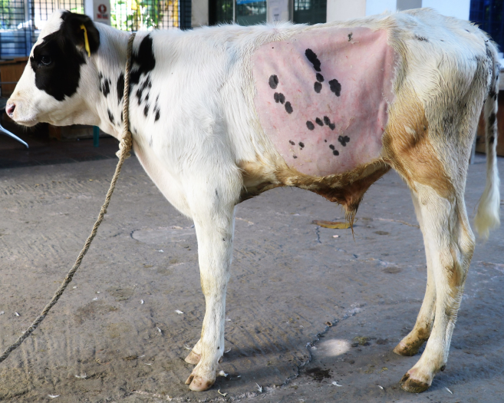

Figure 1. As preoperative preparation, a square area was shavedon the left flank (case no. 1)

**Anesthesia**

The general anaesthesia protocol was used consisting of xylazine and ketamine as well as local anaesthetic lidocaine hydrochloride was used as linear infiltration in all cases and additionally only in case no. 3 distal paravertebral anesthesia of the 1st lumbar nerve was performed. Xylazine (Xylaxin®, Indian immunologicals Ltd, India.) was administered intravenously at 0.1 mg/kg body weight, while ketamine (G-Ketamine® Gonoshasthaya Pharma Ltd., Bangladesh) was administered intravenously at 2.2 mg/kg body weight in all calves. Linear infiltration was performed by injecting 20 ml of 2% lidocaine hydrochloride (Jasocaine® 2%, Joyson Pharmaceuticals Ltd., Bangladesh) in all cases and only in case 3, distal paravertebral anesthesia was performed by 30 ml of 2% lidocaine hydrochloride (Jasocaine® 2%, Joyson Pharmaceuticals Ltd., Bangladesh) around the 1st lumbar nerve. General anesthesia was maintained by intravenously ketamine at 1.5 mg/kg body weight for two times in case no. 1 and 3 and for three times in case no. 2. Intra-operatively lactated ringer’s solution (Lactoride IV®, Beximco Pharmaceuticals Ltd., Bangladesh) was administered intravenously at the rate of 10 ml/kg body weight/hour.

**Surgical procedure**

Splenectomy was performed in all cases as same procedure. The animals were positioned on operating table in right lateral recumbency and the surgical site was aseptically prepared with 7.5% povidone iodine solution and 70% isopropyl alcohol. The surrounding area of operation site was covered with sterile draper with the help of towel clamps. A linear skin incision approximately 15 cm long was made on left flank region particularly parallel and about 5 cm posterior to the last rib (Figure 2). To facilitate the approach of the spleen and splenic vessels, the incision made as high as possible at the angle between the last rib and the transverse process of 1st lumbar vertebra. The right hand was introduced through the incision and directed anteriorly until it reached the spleen located between the rumen and the diaphragm. The connective tissue attachment between the visceral surface of the spleen and rumen was carefully broken blindly by successive digital fenestration. Then the hand was withdrawn and reintroduced between the parietal surface of the spleen and the diaphragm to separate the connection between them. After removing of the attachments, the isolated spleen as well as splenic vessels was clearly visualized and the splenic vessels were clamped with artery forceps. Care was taken to avoid rupture of the splenic artery and vein at the hilus located on the anteromedial aspect of the spleen. With the spleen in place, double ligatures were applied to the splenic vessels with synthetic absorbable suture no. 1 vicryl (Ethicon®, Johnson & Johnson, India). The vessels were then cut distal to the ligature and the forceps were opened slowly to observe whether the ligature had completely excluded the vessels before releasing the stump (Figure 3). Then the spleen was extracted (Figure 4). The abdominal incision was closed in layers in a simple continuous suture pattern using synthetic absorbable suture no.1 vicryl (Ethicon®,Johnson & Johnson, India) and the skin with non-absorbable suture no. 1 silk (Feather®, Anji Hengfeng Sanitary Material Co. Ltd., China) in Horizontal mattress pattern. After completing the surgery, antiseptic ointment was applied on the surgical site as well as the site was covered with a sterile protective bandage (Figure 5). Immediately after the surgery, all calves were oxygenated through face mask for 15-20 minutes and placed in sternal recumbency to recover from anaesthesia.

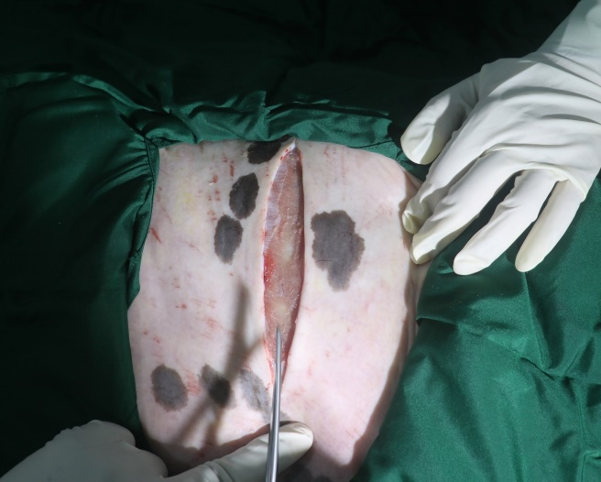

Figure 2. A linear skin incision was made on left flank parallel and posterior to the last rib (case no. 1)

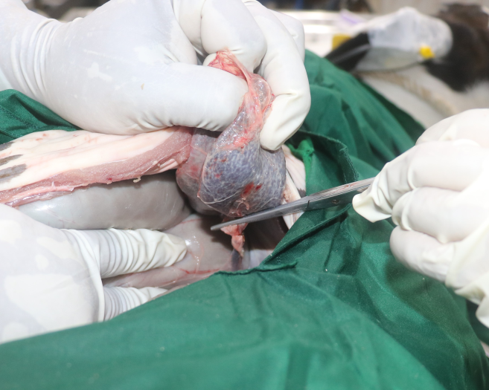Figure 3. After applying double ligature, the vessels were cut distal to the ligature (case no. 1)

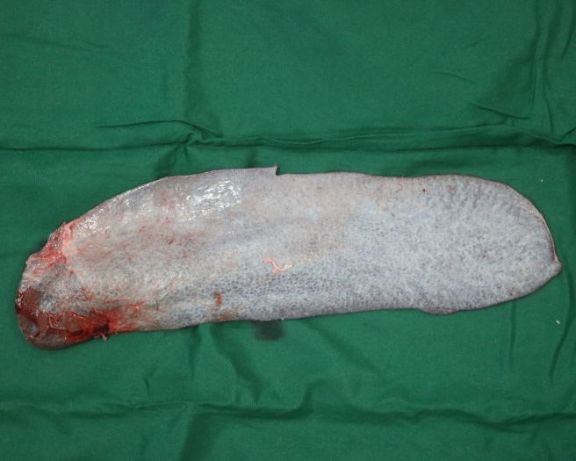

Figure 4. The spleen was exteriorized after dissecting the splenic vessels (case no. 1)

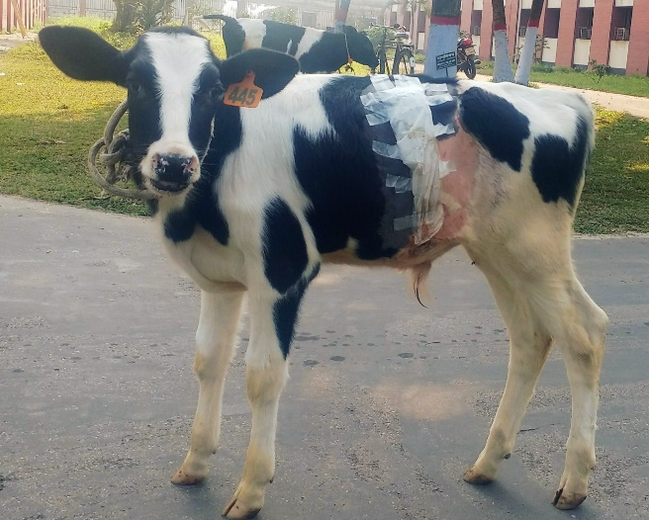

Figure 5. Post-operative day-1, the wound was covered with a sterile bandage (case no. 2) and shown normal activities.

**Post-operative care and monitoring**

A broad spectrum antibiotic ceftriaxone (Ceftron-Vet 1G®, Square Pharmaceuticals Ltd., Bangladesh) was administered intramuscularly at 10 mg/kg body weight for 7 days along with meloxicam (Mel-Vet®, ACME Laboratories Ltd.) at 0.5 mg/kg body weight subcutaneously for 3 days as an analgesic and antihistaminic (Antihista-Vet®, Square Pharmaceuticals Ltd. Bangladesh) at 1mg/kg body weight intramuscularly for 7 days in all calves. 5% povidone iodine ointment (Viodin®, Square Pharmaceuticals Ltd., Bangladesh) was applied topically at the surgical site three times daily for 14 days and covered the wound with a sterile bandage. The responsible personnel of these calves were advised to keep the calves in an enclosed pen with a special facility of mosquito net and advised to offer green grass and water ad libitum. For research purposes, blood was collected from all the calves in different amount and various intervals. In case no. 1, post-operatively blood was collected 250-300 ml for 2 times every 7 days interval and in case no. 2 and 3; 150-170 ml and 250-300 ml blood were collected respectively for three times in every 25-30 days interval. Post-operative monitoring was done via mobile phone and video chat.

1. **RESULTS AND DISCUSSION**

The calves underwent splenectomy with a total anaesthetic duration of 95, 120 and 107 minutes respectively for the calves 1, 2 and 3. Surgeries were smoothly performed in case no. 1 and 3 whereas, in case no. 2 more time was required than other two cases. The respiratory rate and heart rate were not markedly affected from the normal throughout the operation as well as afterwards. All the operated animals withstood the operation very well and recorded to have demonstrated uneventful anaesthetic recovery with specific aftercare. The calves were willing to take their food just after recovery. The surgical wound was healed by primary union without any complication and cutaneous sutures were removed after 14 days of surgery in all cases. Case no. 1 was euthanized at 15th post-operative day. Other two calves were healthy and still survived up to 230th postoperative day with the history of retardation of growth.

Surgical removal of spleen in calves can be challenging to the veterinary surgeon and various standard surgical techniques have been used for splenectomy like splenectomized after resection of the one or last two ribs, operated between the last two ribs and operated just caudal and parallel to the last rib by several researchers with variable results (El-Guindi, 1974; Anosa et al., 1979; Nuss et al., 2009; Zaugg, 1984). Concerning the operation site, the easiest and best way for splenectomy was done after resection of last rib as it gave enough space to ligate the splenic vessels, but the disadvantage registered as taking relatively excess time needed for resection of the rib and the separation of as diaphragm is delicately with the rib (El-Guindi, 1974). The operation site just caudal and parallel to the last rib was the most difficult seat for splenectomy as spleen was far away cranially and had to be removed with difficulty but less time is required and no diaphragmatic tear is found (El-Guindi, 1974). Present research activity was performed by selecting surgical prioritizing to avoid the disadvantages related to life risks of the animals.

The arrest of hemorrhage from the splenic blood vessels was better controlled by double ligature rather than the use of ecraseur owing to the fact that there were large splenic vessels in calves and the crushing might not be enough to arrest hemorrhage permanently (El-Guindi, 1974; Peacock and Manton, 1963). There were majorconcern with the application of the ligature in calves as the inter-abdominal manipulation was not under direct observation. The manipulation of the organ should be completed as far as possible before attempting withdrawal, as it might very easily ruptures and causes unpleasant hemorrhages.

Three deaths were recorded among 23 splenectomized cattle as a result of hemorrhage and surgical shock (Quinlan et al., 1935). However, all calves were survived after surgery in the present study whereas case no. 1 was euthanized 15 days after operation as it did not fulfill the research activities and other two calves were duly survived (195 days) after surgery. Fasting of the calves for 24 hours before all operations were of importance, as it was facilitated pulling out the rumen caudally for better visualization of the spleen and its vessels (El-Guindi, 1974). In case of standing position, sometimes animal was unable to stand and fell down just after starting the operation. So in that study the surgery was completed in the casting recumbent position though sometimes tympany resulting during the operation causes an obstacle in ligating the splenic blood vessels. In contrast, no tympany was developed in the present study; it might be due to young age of the calves and fasting for 24 hours.

Splenectomy was performed in calves either by general anaesthesia or, linear filtration or, paravertebral anaesthesia (El-Guindi, 1974; Anosa et al., 1979; Nuss et al., 2009; Zaugg, 1984). But in this study, both general anaesthesia and linear filtration were performed in all three cases and paravertebral anaesthesia was used only in case no. 3. In calves, general anesthesia should be done to perform surgical interventions that provide good muscle relaxation, full unconsciousness and reduction of motor control. The use of xylazine as a premedication prior to general anaesthesia was excellent as all animals tolerated all the operations under its effect without any reaction. It is suitable to use xylazine-ketamine combination in calves for various surgeries where duration is extended by supplemental use of ketamine (Carroll and Hartsfield, 1996). The use of xylazine as a premedication general anesthesia was excellent because all animals underwent all procedures without experiencing any adverse effects, and it is appropriate to use a combination of xylazine and ketamine in calves for various surgical procedures where the duration is extended by the addition of ketamine.

**4. CONCLUSION**

The present case report suggests that splenectomy in calves can be successfully performed just caudal and parallel to the last rib approach in recumbent position under the combination of general and local anaesthesia protocol and proper postoperative care.

**ACKNOWLEDGEMENT**

The authors indebted to acknowledge the support and cooperation of to Director of Shahedul Alam Quadary Teaching Veterinary Hospital, CVASU and Director General of Bangladesh Livestock Research Institute, Savar for all kinds of technical supports to perform this work successfully. The authors are also thankful to the technicians and stuff for well cooperation by providing valuable information, and post-operative follow up.

# REFERENCES

Anosa, V.O., Isoun, T.T. and Oladosu, L.A. 1979. Splenectomy in sheep technique, haemato-logical changes, and the haematology of the precipitated anaplasmosis and babesiosis. Zentralblatt fur Veterinarmedizin Reihe A, 26: 327-336.

Braun, U. and Sicher, D. 2006. Ultrasonography of the spleen in 50 healthy cows. The Veterinary Journal, 171(3): 513-518.

Carroll, G.L. and Hartsfield, S.M. 1996. General anesthetic techniques in ruminants. Veterinary Clinics of North America: Food Animal Practice, 12: 627-661.

Coetzee, J.F. and Apley, M.D. 2006. Efficacy of enrofloxacin against severe experimental Anaplasma marginale infections in splenectomized calves. Veterinary Therapeutics, 7(3): 319.

El-Guindi, M.H. 1974. Comparative study of the different surgical techniques used for splenectomy in calves with special reference to the operation performed between the last two ribs. Assiut Veterinary Medical Journal, 1: 129-136.

Garcia-Seeber, F., McAuliffe, S.B., McGovern, F. and DeFeo, J. 2008. Splenic rupture and splenectomy in a foal. Equine Veterinary Education, 20: 367-370.

Mittelman, M., Kyzer, S., Zeidman, A., Bendayan, D., Ramadan, E., Cohen, A. and Cahimoff, C. 1997. Splenectomy for haematological diseases-a single institution experience. Haematologia, 28: 185-198.

Nuss, K., Forster, E., Reichert, C., Muggli, E. and Braun, U. 2009. Splenectomy for treatment of suppurative splenitis caused by a reticular foreign body in a heifer. Veterinary Surgery, 38: 477-480.

Peacock, R. and Manton, U.J. 1963. An improved technicue for splenectomy of cattle. Veterinarian, 1: 131-133.

Quinlan, J., De Kock, G. and Marais, I.P. 1935. The operation of splenectomy in horses, cattle, sheep, goats, pigs, dogs and some South African antelopes: A summary of the results of 98 splenectomies.

Robewrtson, J.L. and Newman, S.J. 2000. Disorders of the spleen. In: Feldman BF, Zinkl JG and Jain NC eds. Schalms Veterinary Haematology. 5th edition. Lippincott Williams and Wilkins, Philadelphia, 272-277 pp.

Santos, A.C., Oliveira, D.M., Bertassoli, B.M., Viana, D.C., Vasconcelos, B.G. and Assis-Neto, A.C. 2013. Morphologic features from mdx mice spleens, used for Duchenne Muscular Dystrophy Studies. Journal of Morphological Sciences, 30: 21-27.

Smith, J.J. and Dallap, B.L. 2005. Splenic torsion in an alpaca. Veterinary Surgery, 34: 1-4.

Zaugg, J.L. 1984. Surgical removal of the spleen in American bison. The Journal of Zoo Animal Medicine, 15: 150-152.